F. EXAMPLE PROJECTS WHICH BEST ILLUSTRATE PROPOSED TEAM’S QUALIFICATIONS FOR THIS CONTRACT  (Present as many projects as requested by the agency, or 10 projects, if not specified. Complete one Section F for each project.) |  |  |  |  |  |  | 20. EXAMPLE PROJECT KEY NUMBER  03
21. TITLE AND LOCATION (CITY AND STATE)  Caltrans District 8, SR 138 Widening and Realignment, Wrightwood and Hesperia, CA |  |  |  | 22. YEAR COMPLETED
 |  |  |  | PROFESSIONAL SERVICES  2009 |  |  | CONSTRUCTION (IF APPLICABLE)
23. PROJECT OWNER’S INFORMATION
a. PROJECT OWNER  Caltrans District 8 |  | b. POINT OF CONTACT NAME  Dennis Ozowara, PE, Caltrans Senior Resident Engineer |  |  | c. POINT OF CONTACT TELEPHONE NUMBER  951.232.3741
24. BRIEF DESCRIPTION OF PROJECT AND RELEVANCE TO THIS CONTRACT (INCLUDE SCOPE, SIZE AND COST)
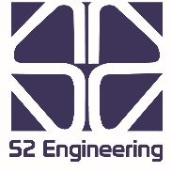
S2 provided construction inspection and materials testing services for this Caltrans project. This was a $30-million construction project that began on the Los Angeles County line and ended at I-15. This 15-mile stretch of SR 138 was widened to add east- and westbound truck climbing lanes and to realign the vertical and horizontal curves for improved sight distance at various locations.

- Pavement Rehabilitation
- Construction Inspection
- Freeway Widening
- Drainage Improvements
- Lane Closures, Flagging, Detours

Project Relevance

Roadway excavation of more than 600,000 m3 was required. There were massive excavations and embankments and 29 drainage systems with depths of invert up to 20m. The widened section of the roadway and some overlay work required 130,000 tons of AC.

The existing highway was a two-lane rural highway, and the work performed with the closure of one lane with flagging. Work on a section of the highway was performed in three shifts with this section completely closed. This required coordination with Caltrans Traffic Management Center, local businesses and residents, the traveling public, CHP, US Forest Service, and local emergency responders.

S2 provided inspection and materials testing services on this project, with a mobile laboratory for construction materials testing. All tests were performed per the requirements of California Tests Methods and Section 6 of Caltrans Construction Manual.
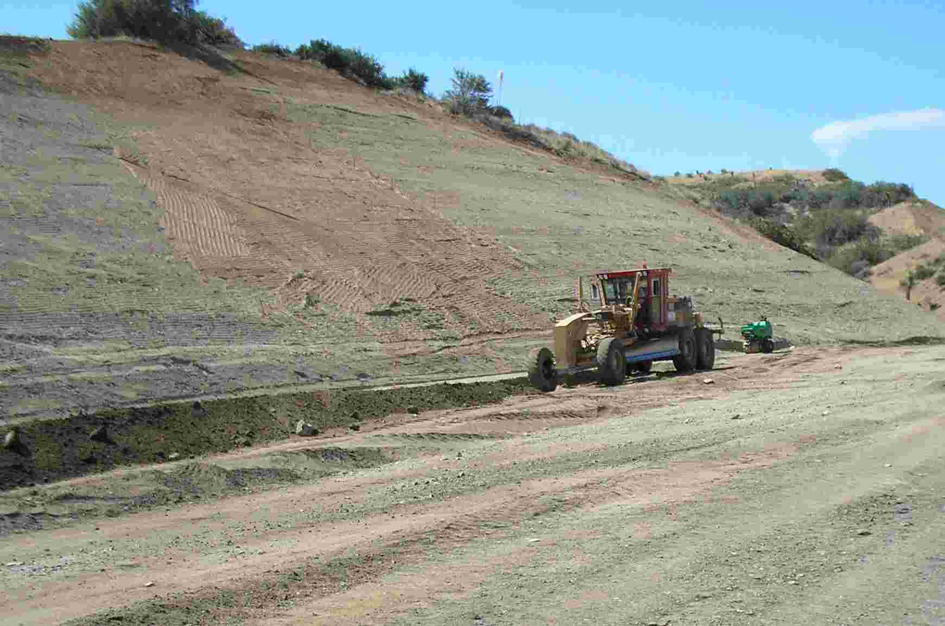

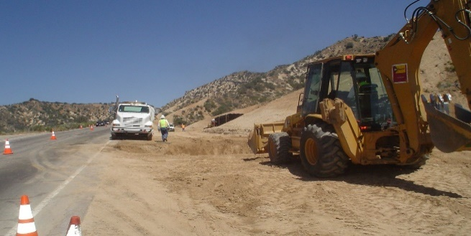

25. FIRMS FROM SECTION C INVOLVED WITH THIS PROJECT
a. | (1) FIRM NAME  S2 Engineering, Inc. |  | (2) FIRM LOCATION (CITY AND STATE)  Rancho Cucamonga, CA |  |  | (3) ROLE  Inspection
STANDARD FORM 330 (REV. 7/2021)

